**Here are** **some fantastic books and resources which help children to understand their feelings and worries and manage them:**

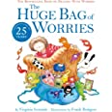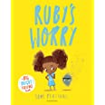

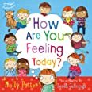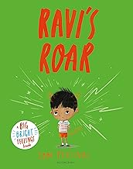

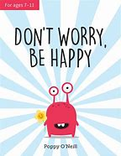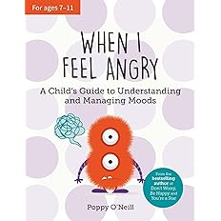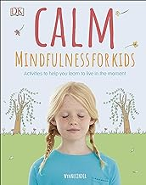

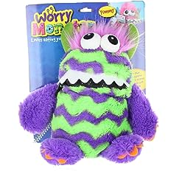

**Worry Monsters are fantastic soft toys which act as a comforter and children can write their worries down and the monster will gobble them up!**

**Making a self soothe box – these can be beneficial to children who need help calming down:**

[Hampshire CAMHS - Make Your Own Self Soothe Box - YouTube](https://www.youtube.com/watch?v=OyfgodSSdV4)